MTCS-103(P)-Parallel Programming
Lab work 16 Report
By
Sai Suraj - 21560

a.
sequential program to perform iterative row-oriented Matrix Multiplication and verified correctness for input size 50. Compiled and ran program for various input sizes. Execution time for various size of matrix is tabulated.

N | Iterative Row-Oriented
50 | 2.85E-04
100 | 1.82E-03
200 | 0.0098426
500 | 0.520807
1000 | 7.795424
2000 | 196.423781

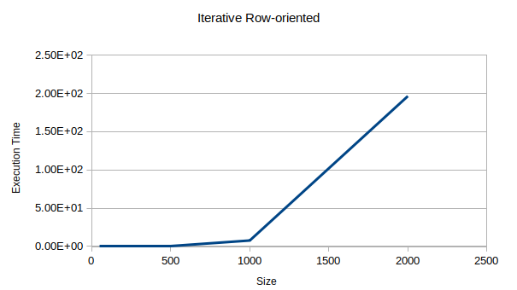

b.
recursive block-oriented Matrix Multiplication and verified correctness for input size 50. Compiled and ran program for various input sizes. Execution time for various size of matrix is tabulated.

N | Recursive Block-Oriented
50 | 1.7E-05
100 | 2.8E-05
200 | 0.000196
500 | 0.001249
1000 | 0.00546
2000 | 0.029445

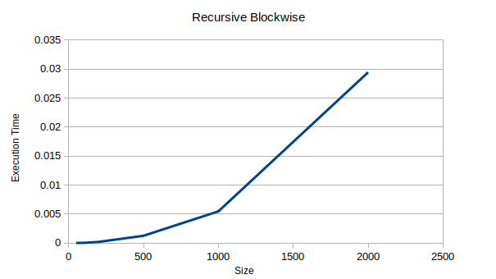

2.
In iterative row-oriented matrix multiplication during each iteration of the outer i loop, every element of matrix B is read. If matrix B is too large for the cache, then later elements read into cache displace earlier elements read into cache, meaning that in the next iteration of the loop indexed by i, all of the elements of B will need to be read into cache again. Hence once the matrices reach a certain size, the cache hit rate falls dramatically, lowering the performance of the CPU.In recursive block-oriented matrix multiplication during each iteration of the outer i loop, every element of matrix B is read. If matrix B is too large to fit into cache, we can divide it into four pieces and use the idea of block matrix multiplication to compute C. in block B, j is too large to fit into cache, we can apply this idea recursively until we have blocks that do fit in cache.

3.
In iterative row-oriented matrix multiplication algorithm if the memory size is smaller, then the execution time increases rapidly.In recursive block-oriented matrix multiplication algorithm if memory size is smaller, then execution time will increase. If memory size is larger, then execution time will decrease.

4.
When matrix B no longer fits in the cache, the performance of the row-oriented matrix multiplication algorithm drops sharply. the recursive block-oriented matrix multiplication algorithm maintains high performance, even as the sizes of the matrices grow well beyond the cache capacity.it also keeps the cache hit rate high and achieves better performance than the row-oriented algorithm.

